**COGNIZANT**

**Week- Hands on**

**Assignments**

**Microservices with Spring Boot 3 and Spring Cloud**

**Name: *Saranya S***

**Super Set ID: *6372488***

**E-mail:727822tuit210@skct.edu.in**

**Question-1(Creating microservices for account and loan)**

**AccountController.java**

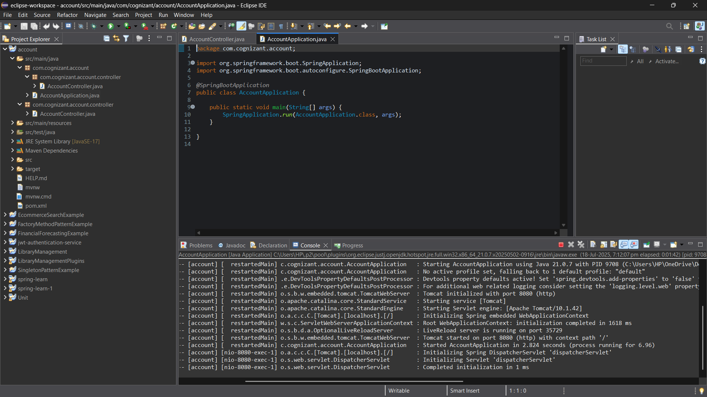

**Output**

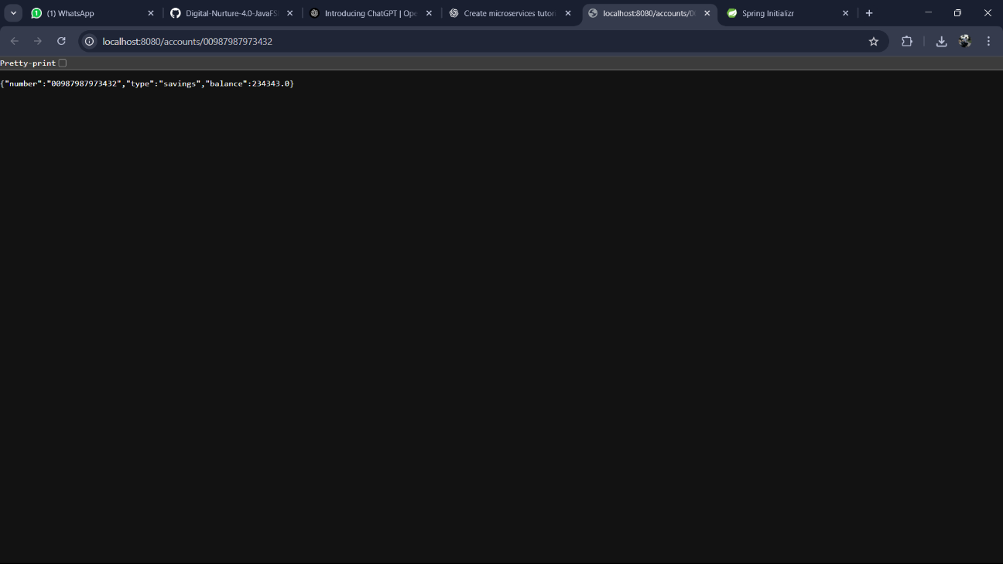

**LoanController.java**

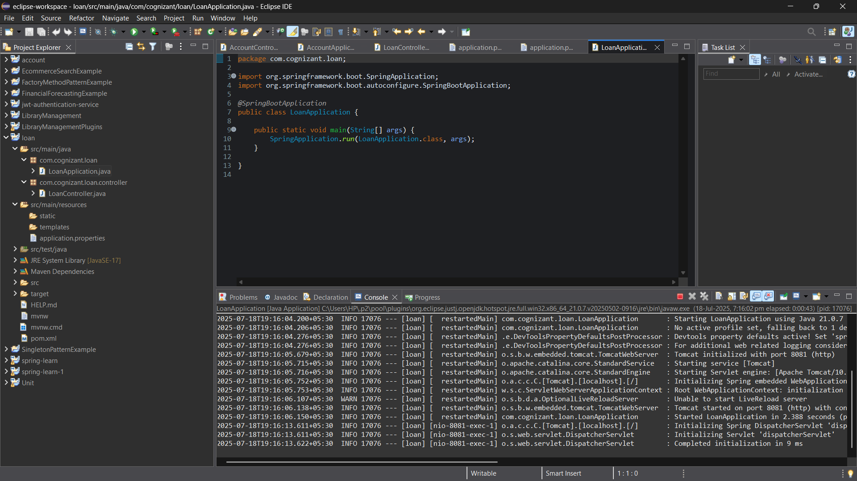

**Output**

